Name : PEDDI SAI KRISHNA
Reg. Number : RA2111003011310
Department and Section : CSE H2

INDEX
S.NO | TITLE | PAGE NO
1 | Introduction | 2
2 | Aim of the Project | 2
2.1 | Advantages | 2
2.2 | Disadvantages | 3
3 | Software & Hardware Details | 3
4 | Algorithm for each module | 4
5 | Implementation | 5
6 | Result And Testing | 10
7 | Conclusion | 11

1.INTRODUCTION
Dictionary is an abstract data structure that supports the following operations: search(K key) (returns the value associated with the given key)
The various operations that are performed on a Dictionary or associative array are:
- Add or Insert: In the Add or Insert operation, a new pair of keys and values is added in the Dictionary or associative array object.
- Replace or reassign: In the Replace or reassign operation, the already existing value that is associated with a key is changed or modified. In other words, a new value is mapped to an already existing key.
- Delete or remove: In the Delete or remove operation, the already present element is unmapped from the Dictionary or associative array object.
- Find or Lookup: In the Find or Lookup operation, the value associated with a key is searched by passing the key as a search argument.

2.AIM

Creating Dictionary Using Linked List And Adding Functions.

2.1

Advantage of Data Dictionary
There is lot of advantages of data dictionary. Some of main points are
- It gives the well structured and clear information about the database. One can analyse the requirement, any redundancy like duplicate columns, tables etc. Since it provides a good documentation on each object, it helps to understand the requirement and design to the great extent.
- It is very helpful for the administrator or any new DBA to understand the database. Since it has all the information about the database, DBA can easily able to track any chaos in the database.
- Since database is a very huge, and will have lots of tables, views, constraints, indexes etc, it will be difficult for anyone to remember. Data dictionary helps user by providing all the details in it.

2.2

Disadvantages of Data Dictionary
- Creating a new data dictionary is a very big task. It will take years to create one.
- It should be well designed in advance to take all the advantages of it. Otherwise, it will create problems throughout its life.
- The cost of data dictionary will be bit high as it includes its initial build and hardware charges as well as cost of maintenance.
- Non technical users will not understand what the columns in the data dictionary views are. It meant only for technical users

3.SYSTEM REQUIREMENTS

- SOFTWARE REQUIREMENTS:
The major software requirements of the project are as follows:
Language : C
Operating system: Windows 10.

- HARDWARE REQUIREMENTS:
The hardware requirements that map towards the software are as follows:
RAM : 1TB
Processor : INTEL

4.ALGORITHM
Doublely Linked list:
Create( ):
Step-1: start.
Step-2: Insert the data types with respect to variables.
Step-3: Insert the details of the variables.
Step-3: Read the variables.
Step-4: store the variables in the form of arrays.
Step-5: Then give the key value.
Insert( ):
Step-1: Give all the variables details.
Step-2: Then give the program to print the elements in the form of table.
Step-3: Give the print statement to enter the elements.
Step-4: Give the scan statement to store the elements in the program
Step-5 Give the condition that I value is initially equals to 0, I should be less than n value, I should be incremented.
Search( ):
Step-1: Give the command to read variables for hashing.
Step-2: Give the print statement to get the output.
Step-3: In that print statement give the variables details to get that particular item.
Step-4: Now, compile the program.
Step-5: If it compiles properly. Then run the program.
Step-6: Stop.

5. IMPLEMENTATION
#include <stdio.h>
#include <stdlib.h>

struct dict {
struct dict *left,*right;
char word[10],meaning[20];
}*Root=NULL;

typedef struct dict dictionary;
int check(char[],char[]);
void insert(dictionary *);
void Search();
void view(dictionary *);

int check(char a[],char b[]){
int i,j,c;
for(i=0,j=0 ; a[i]!='\0'&&b[j]!='\0' ; i++,j++){
if(a[i]>b[j]){
c=1;
break;
}
else if(b[j]>a[i]){
c=-1;
break;
}
else
c=0;
}
if(c==1)
return 1;
else if(c==-1)
return -1;
else
return 0;
}

void Search(){
int flag=0;
dictionary *ptr;
ptr=Root;
char w[10];
printf("\nEnter word");
scanf("%s",w);
while(ptr!=NULL && flag==0){
if(check(w,ptr->word)>0)
ptr=ptr->right;
else if(check(w,ptr->word)<0)
ptr=ptr->left;
else if(check(w,ptr->word)==0){
flag=1;
printf("\n%s",ptr->meaning);
}

}
if(flag==0)
printf("\nWord not found");
}

void insert(dictionary *temp){
int flag=0;
dictionary *ptr,*par;
ptr=Root;

if(Root==NULL)
Root=temp;
else{
while(ptr!=NULL ){
if(check(temp->word,ptr->word)>0){
par=ptr;
ptr=ptr->right;
}

else if(check(temp->word,ptr->word)<0)
{
par=ptr;
ptr=ptr->left;
}
else if(check(temp->word,ptr->word)==0){
flag=1;
printf("\nWord exists!!");
break;
}

}
if(flag==0 && ptr==NULL){

if(check(par->word,temp->word)==1)
par->left=temp;
else if(check(par->word,temp->word)==-1)
par->right=temp;
}

}

}

void view(dictionary *ptr){
if(Root==NULL)
printf("\nEmpty dictionary\n");

else if(ptr !=NULL){
view(ptr->left);

printf("\nWord:%s\n",ptr->word);
printf("\nMeaning:%s\n",ptr->meaning);

view(ptr->right);
}

}

int main(int argc, char const *argv[]) {
int ch;
dictionary *temp;
while(ch!=4){
printf("\n1.Search\n2.Insert\n3.View\n4.Exit\nYour choice please..");
scanf("%d",&ch);
switch (ch) {
case 1: Search();break;
case 2:
temp=(dictionary*)malloc(sizeof(dictionary));
temp->left=NULL;
temp->right=NULL;
printf("\nInsert word:\n");
scanf("%s",temp->word);
printf("\nInsert meaning:\n");
scanf("%s",temp->meaning);
insert(temp);
break;
case 3:
view(Root);
break;
case 4:exit(0);
}
}
return 0;
}
6.RESULT AND TESTING
OUTPUTS:
Screen Shots:
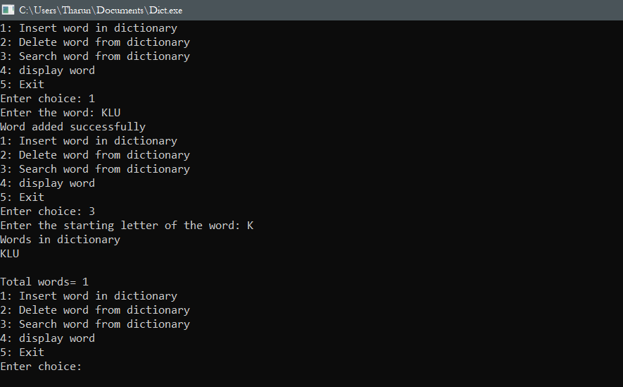

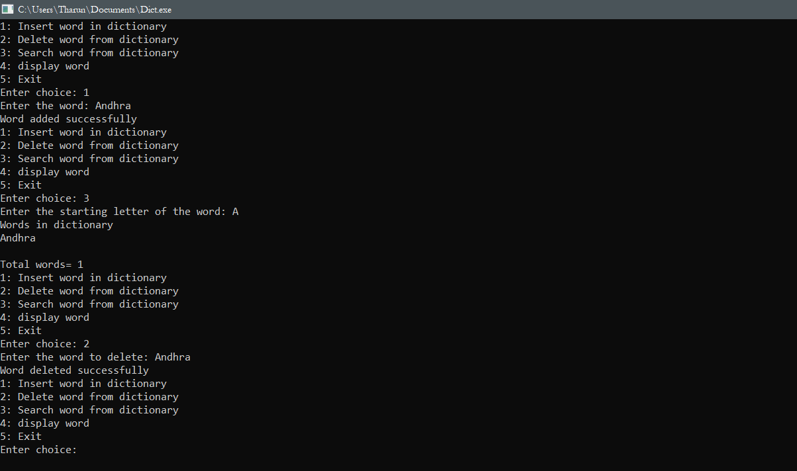

7. CONCLUSION
We have successfully completed the implementation of dictionary. In this we inserted, deleted, searched, and displayed the words. After we executed the program successfully and got the output. In this we learned the perfect hashing we are able to understand the program very clearly and got good results. This is also very useful for reference those who are studying hash program and creating so many dictionaries.

